Introduction to HTML Part 2 (Code Club)
Task 1 (last week)
- Open Notepad
- Copy this text:
<!DOCTYPE html>
<html>

<head>
<title>My first web page</title>
</head>

<body>
<h1>My first web page</h1>
<br>
<br>
<h2>What this is</h2>
<p>A simple page put together using HTML</p>
<h2>Why this is</h2>
<p>To learn HTML</p>

<a href="http://www.dtrofimczuk.co.uk ">Darren’s Website</a>

<table style="width:100%">
<tr>
<td>Jill</td>
<td>Smith</td>
<td>50</td>
</tr>

</body>
</html>

Support Links:
http://www.w3schools.com/html/default.asp

Task 2-Background Colour

<body style="background-color:RED;">

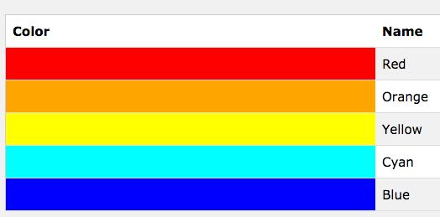
TASK 3- Links:
- Website Links:
<a href="http://www.dtrofimczuk.co.uk ">Darren’s Website</a>

- Pictures:
<img src="darren.jpg" alt="Darren picture" width="128" height="128">

- Pages:
<A HREF="about.html">About this site</A>
or
<A HREF="pages/about.html">About this site</A>
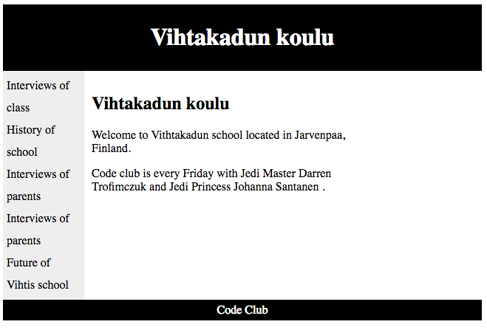
TASK 4 LAYOUTS:
<!DOCTYPE html>
<html>
<head>
<style>
#header {
background-color:black;
color:white;
text-align:center;
padding:5px;
}
#nav {
line-height:30px;
background-color:#eeeeee;
height:300px;
width:100px;
float:left;
padding:5px;
}
#section {
width:350px;
float:left;
padding:10px;
}
#footer {
background-color:black;
color:white;
clear:both;
text-align:center;
padding:5px;
}
</style>
</head>
<body>

<div id="header">
<h1>Vihtakadun koulu</h1>
</div>

<div id="nav">
Interviews of class<br>
History of school<br>
Interviews of parents<br>
Interviews of parents<br>
Future of Vihtis school
</div>

<div id="section">
<h2>Vihtakadun koulu</h2>
<p>Welcome to Vithtakadun school located in Jarvenpaa, Finland.
</p>
<p>Code club is every Friday with Jedi Master Darren Trofimczuk and Jedi Princess Johanna Santanen
.</p>
</div>

<div id="footer">
Code Club
</div>

</body>
</html>

